Ultralytics YOLOv8 Object Detection Model - Detection, Segmentation and Classification (Custom Dataset)
Computer vision is a field of artificial intelligence that deals with how computers can be made to interpret and understand visual data from the world, such as images and videos. This includes tasks such as image recognition, object detection, and image segmentation. Computer vision techniques are used in a wide range of applications including self-driving cars, robotics, and image search engines.
Object detection is a computer technology related to computer vision and image processing that deals with detecting instances of semantic objects of a certain class (such as humans, buildings, or cars) in digital images and videos with the goal of locating and recognizing objects. It can be used in various applications such as self-driving cars, video surveillance, image retrieval, and object tracking. There are many algorithms and techniques used for object detection, some of the most popular include:
- Scale-Invariant Feature Transform (SIFT)
- Speeded Up Robust Features (SURF)
- Fast R-CNN
- You Only Look Once (YOLO)
- Single Shot MultiBox Detector (SSD)
- RetinaNet
Those are some of the most common algorithms used, others are being continually developed. The choice of the algorithm depends on the use-case and the resources available.
Image segmentation is the process of partitioning a digital image into multiple segments (sets of pixels, also known as super-pixels) with the goal of simplifying the representation of an image into something that is more meaningful and easier to analyse. It is a crucial step in image analysis and computer vision. The resulting segments can be used for object recognition, image compression, and image editing.
There are various techniques for image segmentation, including:
- Thresholding: which divides an image into multiple segments based on a threshold value.
- Watershed algorithm: which is based on the idea of "flooding" an image from markers and creating boundaries between different regions.
- Clustering: which groups similar pixels together based on color, texture, or other features.
- Convolutional Neural Networks (CNNs): which are trained to perform image segmentation tasks.
- Graph-based methods: which use graph theory to model the image as a network of connected pixels.
The choice of the algorithm depends on the use-case, the resources available, and the desired level of accuracy.
YOLO (You Only Look Once) is a real-time object detection system, which is a single convolutional neural network (CNN) that can detect multiple objects in an image. It was first introduced in a research paper in 2016 by Joseph Redmon and Ali Farhadi.
YOLO works by dividing the input image into a grid of cells and for each cell, it predicts the bounding boxes of objects and the class probabilities. Each grid cell is responsible for predicting a fixed number of bounding boxes. It uses anchor boxes, which are the prior knowledge of the dimensions of objects that the model should detect. YOLO then uses a non-maximum suppression algorithm to remove redundant bounding boxes and keep only the most confident predictions.
The main advantage of YOLO is its speed, it can process images in real-time, making it well suited for applications such as video surveillance, self-driving cars, and robotics. However, it can also suffer from a lower accuracy compared to other object detection algorithms like Faster R-CNN and RetinaNet.
YOLO has multiple versions, that improve the accuracy and support more features, those are YOLOv2, YOLOv3, YOLOv4, YOLOv5, YOLOv6, YOLOv7 and YOLOv8.
- YOLOv8 is the latest version of the YOLO object detection and image segmentation model developed by Ultralytics
- YOLOv8 is a state-of-the-art (SOTA) model that introduces new features and improvements to enhance performance and flexibility
- YOLOv8 is extensible, it supports all previous versions of YOLO, allowing users to switch between different versions and compare their performance
- YOLOv8 includes new innovations such as a new backbone network, a new anchor-free detection head, and a new loss function
- YOLOv8 can run on a variety of hardware platforms efficiently, from CPUs to GPUs
- YOLOv8 offers the latest SOTA technology and the ability to use and compare all previous YOLO versions, making it a powerful and flexible tool for object detection and image segmentation.
- YOLOv8 was developed by Glenn Jocher at Ultralytics, who shadowed the YOLOv3 repo in PyTorch, a deep learning framework from Facebook.
- Ultralytics eventually launched its own model: YOLOv5, which quickly became the world's state-of-the-art (SOTA) repo due to its flexible Pythonic structure.
- The YOLOv5 maintainers have been committed to supporting a healthy software ecosystem around the model, they actively fix issues and push the capabilities of the repository as the community demands.
- Various models have been branched off of the YOLOv5 PyTorch repository, including Scaled-YOLOv4, YOLOR, and YOLOv7.
- Other models emerged around the world out of their own PyTorch based implementations, such as YOLOX and YOLOv6.
- Ultralytics worked on researching the newest SOTA version of YOLO, YOLOv8, which was launched on January 10th, 2023.
- Each YOLO model has brought new SOTA techniques that continue to push the model's accuracy and efficiency.

YOLOv8 Model Architecture Updates
- YOLOv8 is the latest version of the YOLO object detection model, but currently, it does not have a published paper, so the research methodology and ablation studies used during its creation are not publicly available.
- However, by analysing the repository and information available about the model, we can document the new features and improvements in YOLOv8.
- To examine the code, one can check out the YOLOv8 repository and compare it with previous versions to see how the research was done.
- Here, we will provide a summary of the most significant updates in the model and evaluate its performance based on the available information.
- A detailed visualization of the model's architecture can be found in the following image made by GitHub user RangeKing.
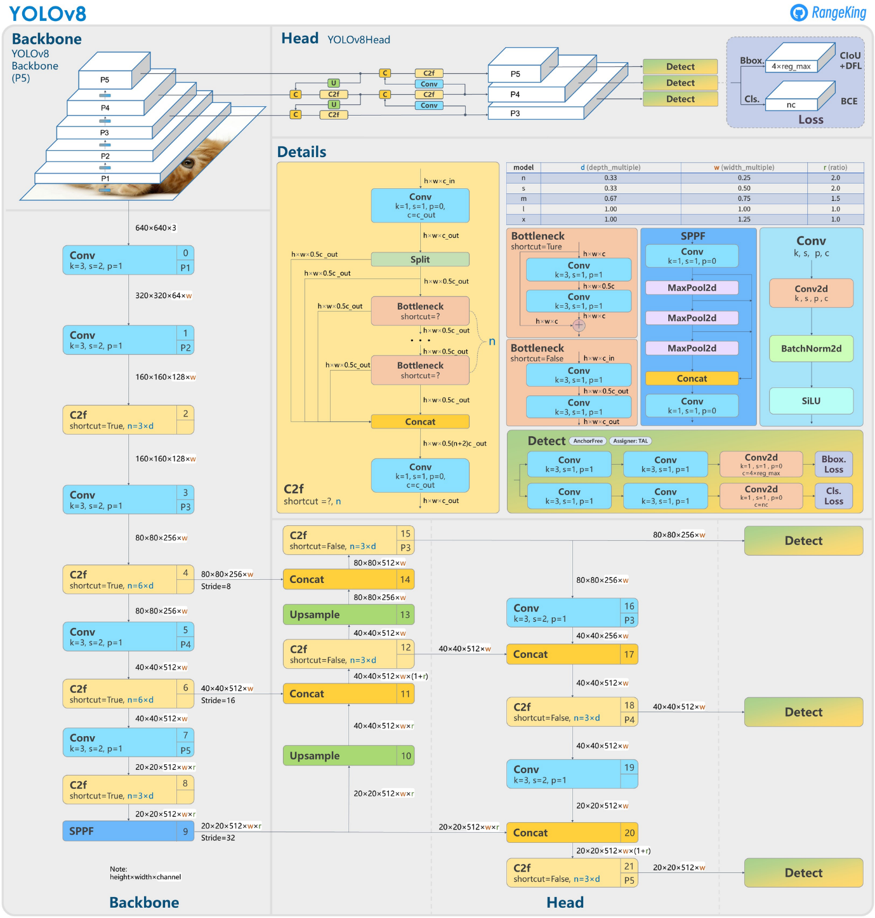

Anchor Free Detection
YOLOv8 is an anchor-free model. This means it predicts directly the centre of an object instead of the offset from a known anchor box.
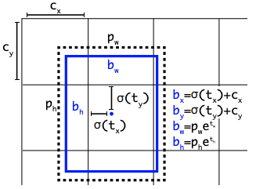

Visualization of an anchor box in YOLO

Anchor boxes were a notoriously tricky part of earlier YOLO models, since they may represent the distribution of the target benchmark's boxes but not the distribution of the custom dataset.
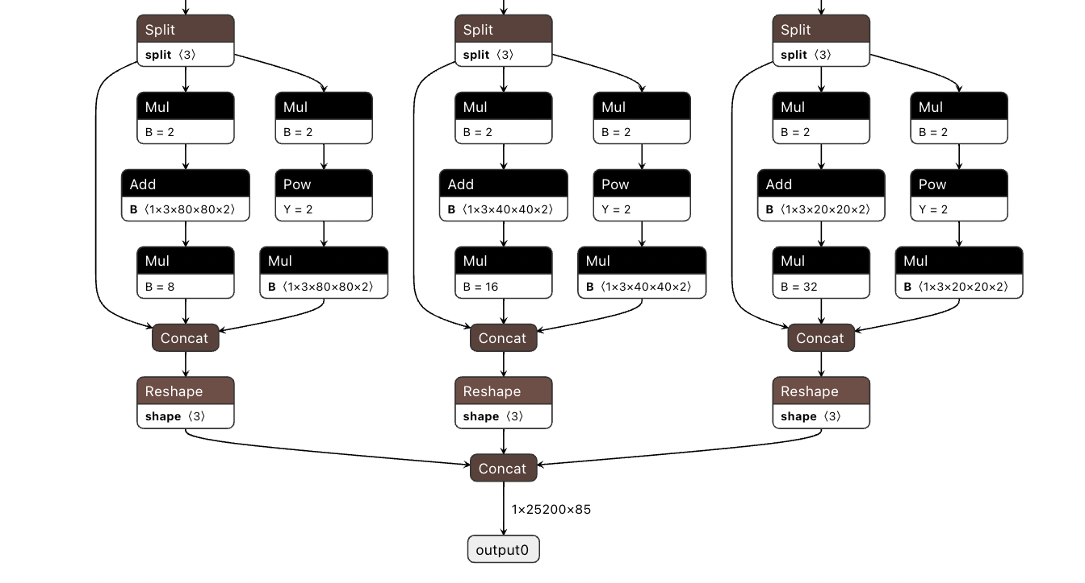The detection head of YOLOv5

Anchor free detection reduces the number of box predictions, which speeds up Non-Maximum Suppression (NMS), a complicated post processing step that sifts through candidate detections after inference.
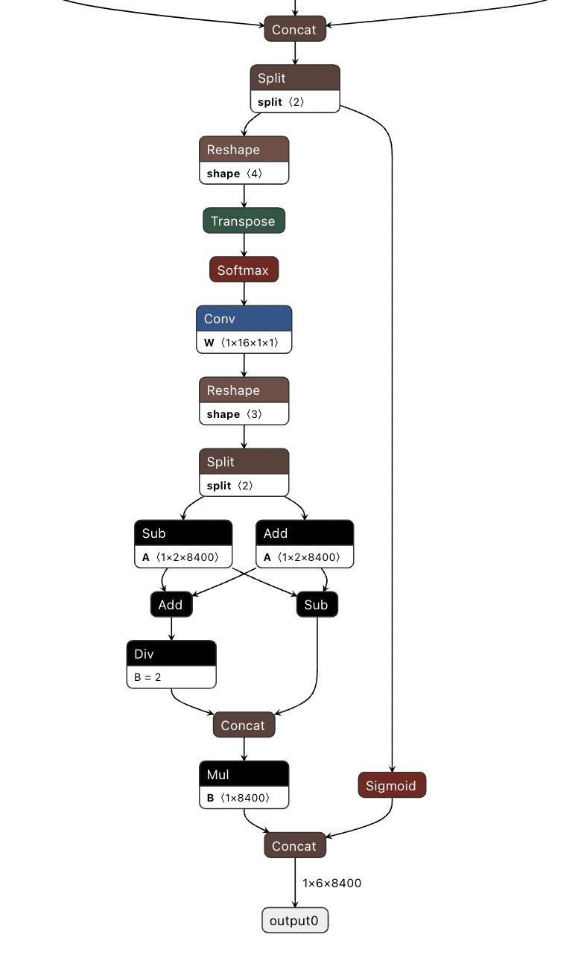
The detection head for YOLOv8,

New Convolutions
The stem's first 6x6 conv is replaced by a 3x3, the main building block was changed, and C2f replaced C3 . The module is summarized in the picture below, where "f" is the number of features, "e" is the expansion rate and CBS is a block composed of a Conv, a BatchNorm and a SiLU later.
In C2f, all the outputs from the Bottleneck (fancy name for two 3x3 convs with residual connections) are concatenated. While in C3 only the output of the last Bottleneck was used.
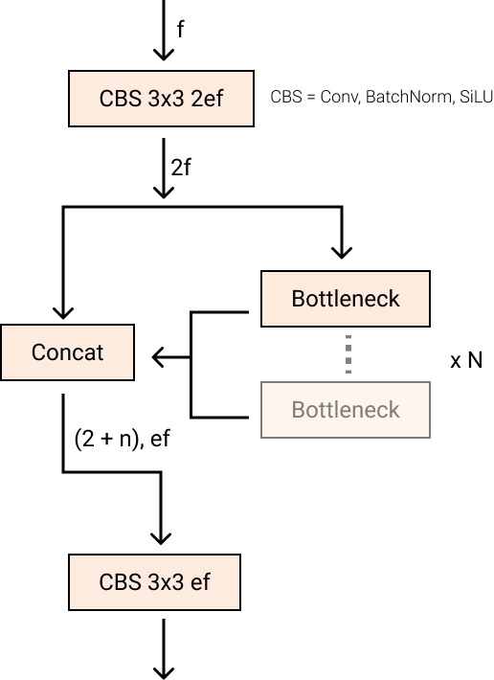
New YOLOv8 C2f module
The Bottleneck is the same as in YOLOv5 but the first conv's kernel size was changed from 1x1 to 3x3. From this information, we can see that YOLOv8 is starting to revert to the ResNet block defined in 2015.
In the neck, features are concatenated directly without forcing the same channel dimensions. This reduces the parameters count and the overall size of the tensors.

Closing the Mosaic Augmentation
Deep learning research tends to focus on model architecture, but the training routine in YOLOv5 and YOLOv8 is an essential part of their success.
YOLOv8 augments images during training online. At each epoch, the model sees a slightly different variation of the images it has been provided.
One of those augmentations is called mosaic augmentation. This involves stitching four images together, forcing the model to learn objects in new locations, in partial occlusion, and against different surrounding pixels.
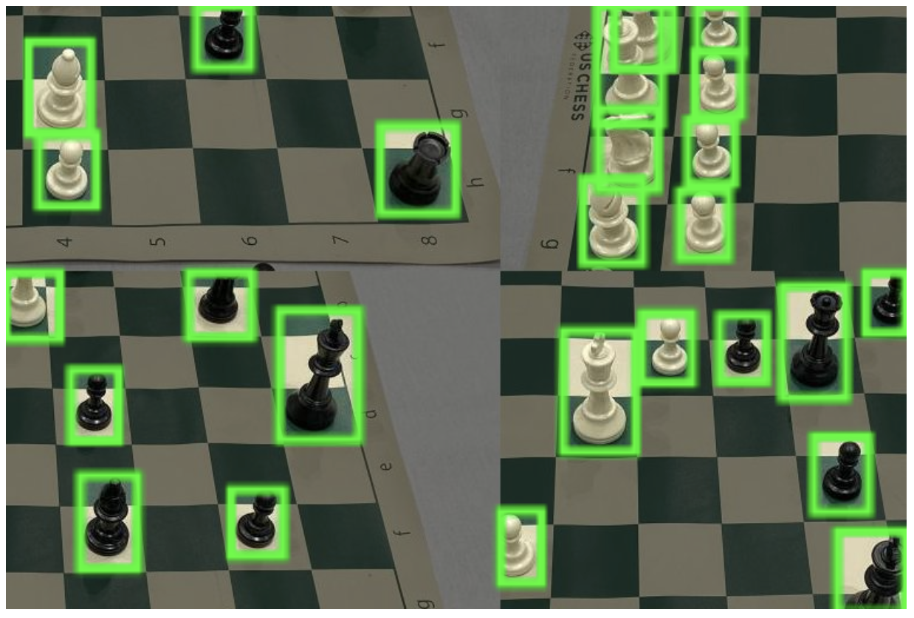Mosaic augmentation of chess board photos
However, this augmentation is empirically shown to degrade performance if performed through the whole training routine. It is advantageous to turn it off for the last ten training epochs.
This sort of change is exemplary of the careful attention YOLO modeling has been given in overtime in the YOLOv5 repo and in the YOLOv8 research.

YOLOv8 Accuracy Improvements
YOLOv8 research was primarily motivated by empirical evaluation on the COCO benchmark. As each piece of the network and training routine are tweaked, new experiments are run to validate the changes effect on COCO modeling.

YOLOv8 COCO Accuracy
COCO (Common Objects in Context) is the industry standard benchmark for evaluating object detection models. When comparing models on COCO, we look at the mAP value and FPS measurement for inference speed. Models should be compared at similar inference speeds. The image below shows the accuracy of YOLOv8 on COCO, using data collected by the Ultralytics team and published in their YOLOv8 README:
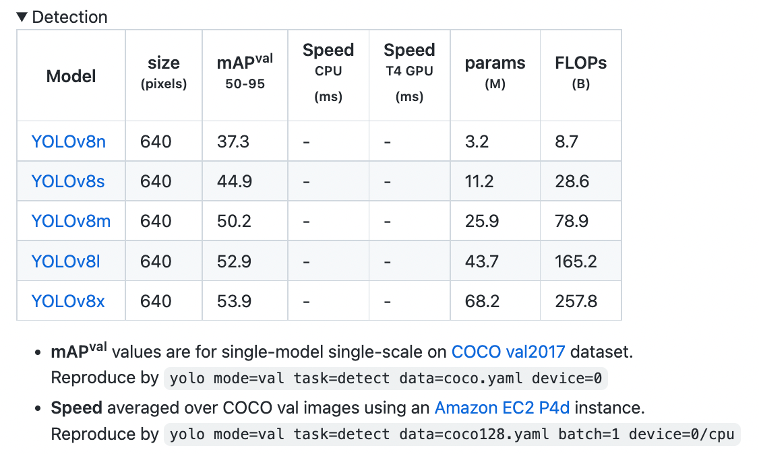

YOLOv8 COCO evaluation
YOLOv8 COCO accuracy is state of the art for models at comparable inference latencies as of writing this post.

RF100 Accuracy
At Roboflow, we have drawn 100 sample datasets from Roboflow Universe, a repository of over 100,000 datasets, to evaluate how well models generalize to new domains. Our benchmark, developed with support from Intel, is a benchmark for computer vision practitioners designed to provide a better answer to the question: "how well will this model work on my custom dataset?"
We evaluated YOLOv8 on our RF100 benchmark alongside YOLOv5 and YOLOv7, the following box plots show each model's mAP@.50.
We run the small version of each model for 100 epochs, we ran once with a single seed so due to gradient lottery take this result with a grain of salt.
The box plot below tells us YOLOv8 had fewer outliers and an overall better mAP when measured against the Roboflow 100 benchmark.
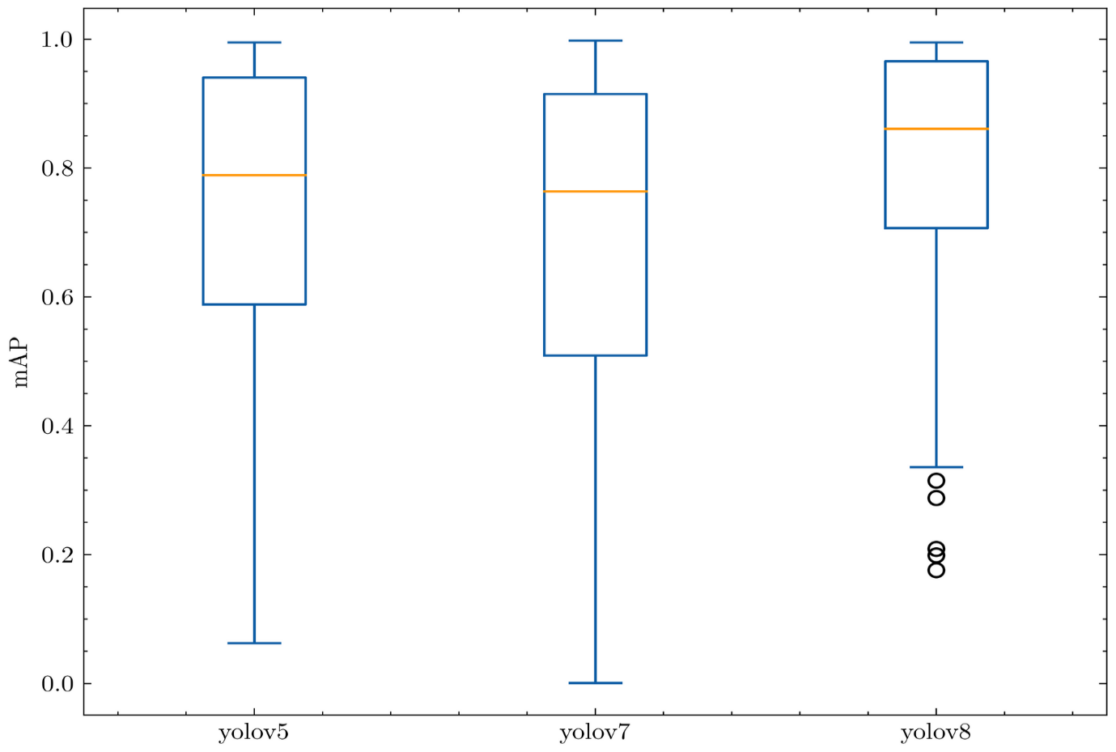YOLOs mAP@.50 against RF100
The following bar plot shows the average mAP@.50 for each RF100 category. Again, YOLOv8 outperforms all previous models.
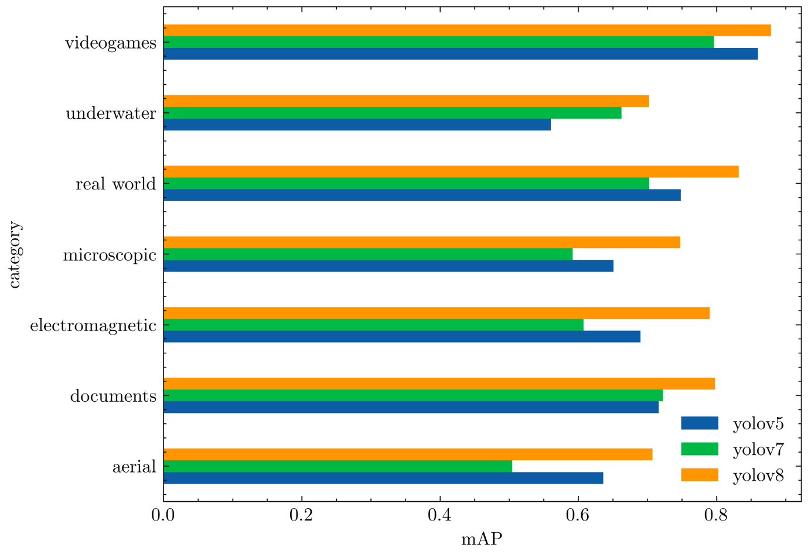YOLOs average mAP@.50 against RF100 categories
Relative to the YOLOv5 evaluation, the YOLOv8 model produces a similar result on each dataset, or improves the result significantly.

YOLOv8 vs YOLOv7 vs YOLOv6 vs YOLOv5
Right away, YOLOv8 models seem to perform much better compared to the previous YOLO models. Not only YOLOv5 models, YOLOv8 is ahead of the curve against YOLOv7 and YOLOv6 models also.
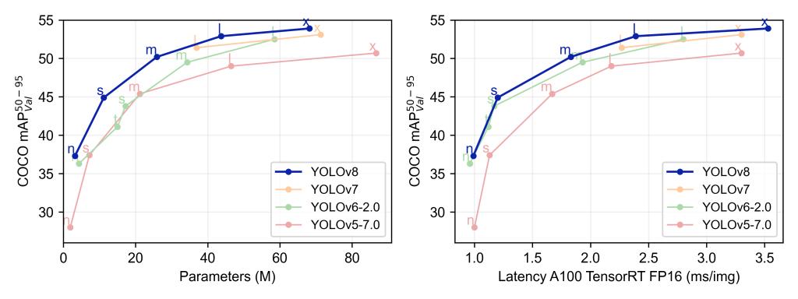YOLOv8 compared with other YOLO models.
When compared with other YOLO models trained at 640 image resolution, all the YOLOv8 models have better throughput with a similar number of parameters.
Now, let’s take a detailed view of how the latest YOLOv8 models perform in comparison with the YOLOv5 models from Ultralytics. The following tables show a comprehensive comparison between YOLOv8 and YOLOv5.

Overall Comparison
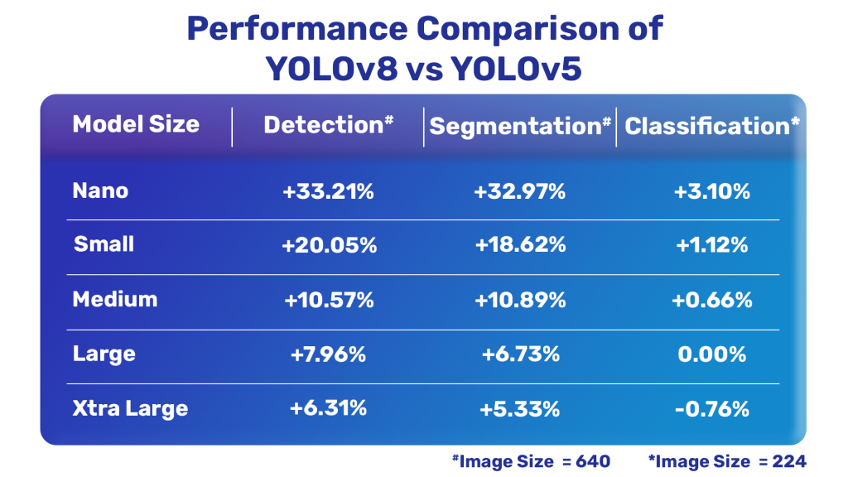YOLOv8 models compared with YOLOv5 models.

Object Detection Comparison
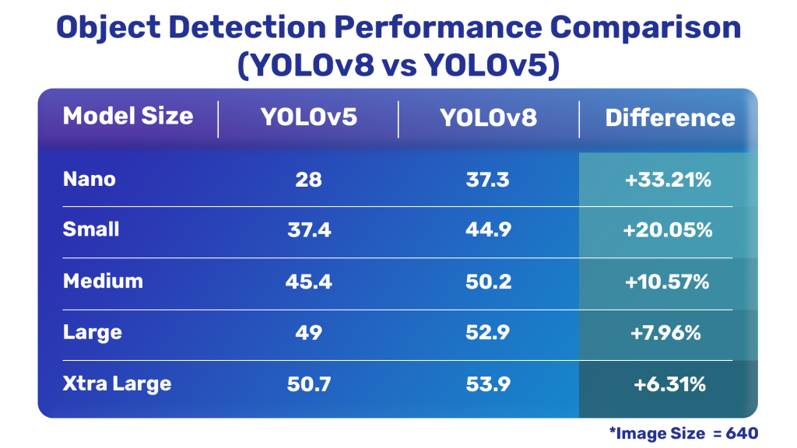YOLOv8 vs YOLOv5 object detection models.

Instance Segmentation Comparison
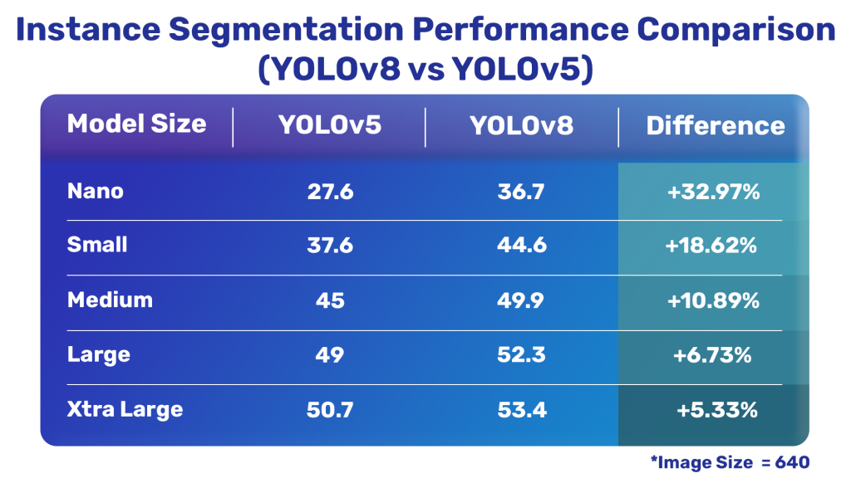YOLOv8 vs YOLOv5 instance segmentation models.

Image Classification Comparison
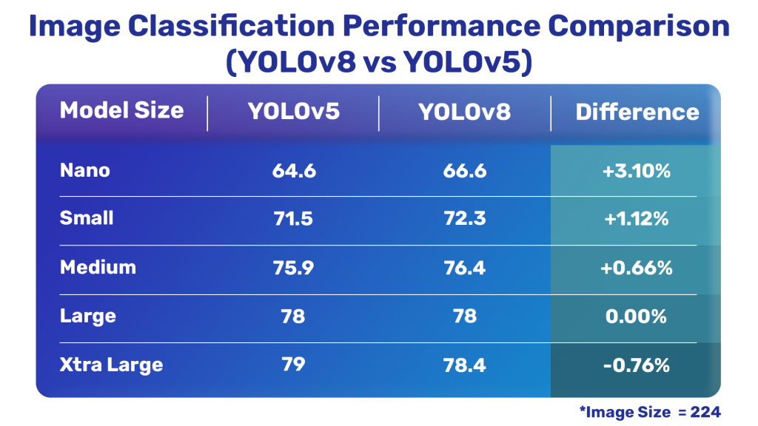YOLOv8 vs YOLOv5 image classification models.
It is clear that the latest YOLOv8 models are much better compared to YOLOv5 except for one of the classification models.

YOLOv8 Repository and PIP Package
The YOLOv8 code repository is designed to be a place for the community to use and iterate on the model. Since we know this model will be continually improved, we can take the initial YOLOv8 model results as a baseline, and expect future improvements as new mini versions are released.
The best outcome that we can hope for is that researchers begin to develop their networks on top of the Ultralytics repository. Research has been happening in forks of YOLOv5, but it would be better if models were made in one location and eventually merged into the main line.

YOLOv8 Repository Layout
The YOLOv8 models utilize similar code to YOLOv5 with new structure where classification, instance segmentation, and object detection task types are supported with the same code routines. Models are still initialized with the same YOLOv5 YAML format and the dataset format remains the same as well.

Ultralytics YOLOv8 Object Detection Model - Detection, Segmentation, and Classification (Custom Dataset)
- Computer Vision Overview:
  - Field of artificial intelligence interpreting visual data.
  - Includes image recognition, object detection, and segmentation.
  - Applied in self-driving cars, robotics, and image search engines.
- Object Detection:
  - Identifies instances of objects (e.g., humans, buildings) in images or videos.
  - Applications: self-driving cars, video surveillance, image retrieval.
  - Popular algorithms: SIFT, SURF, Fast R-CNN, YOLO, SSD, RetinaNet.
- Image Segmentation:
  - Divides digital images into segments for analysis.
  - Techniques: Thresholding, Watershed algorithm, Clustering, CNNs, Graph-based methods.
- YOLO (You Only Look Once):
  - Real-time object detection system using a single CNN.
  - Introduced in 2016 by Joseph Redmon and Ali Farhadi.
  - Speed advantage but may have lower accuracy compared to some algorithms.
- YOLOv8 Model:
  - Latest version developed by Ultralytics, introduced in January 2023.
  - Key Features:
    - Anchor-Free Detection.
    - New Convolutions in model architecture.
    - Closure of Mosaic Augmentation for improved performance.
    - Accuracy Improvements on COCO benchmark and RF100 Accuracy.
- Performance Comparison:
  - Outperforms YOLOv5, YOLOv7, and YOLOv6 in terms of mAP@.50.
  - Better throughput and similar parameter count at 640 image resolution.
- Repository and PIP Package:
  - YOLOv8 repository for community use and iteration.
  - Similar code structure to YOLOv5 with enhancements.
  - Models initialized with YOLOv5 YAML format and dataset format.

